LS02-EC2-NAT-Gateway

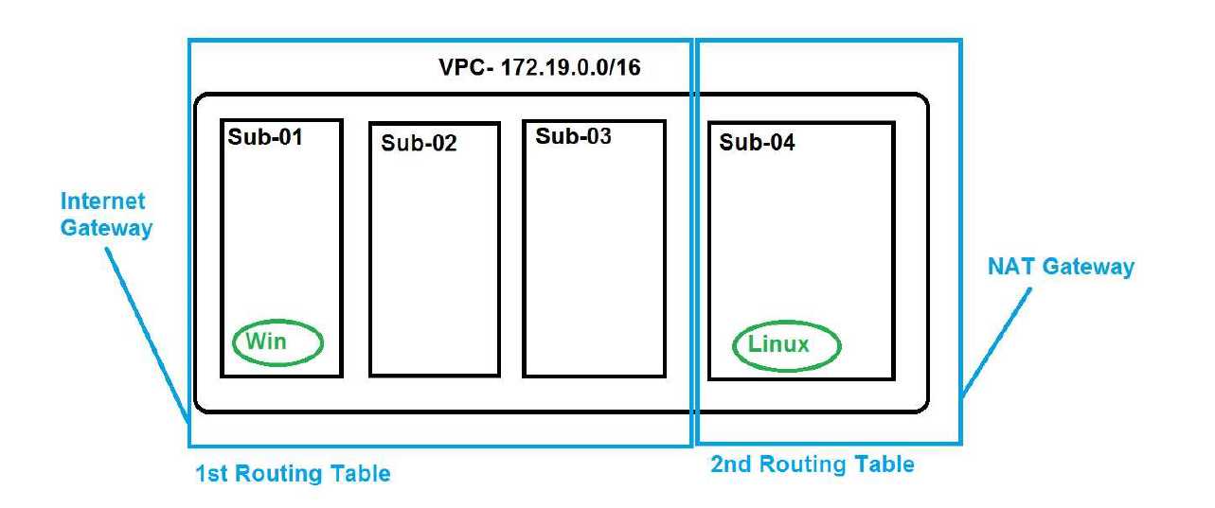
Region- 1 – North Virginia
Create an VPC, with 172.19.0.0/16
500 IP’s in each Network
Create 4 Subnets.
ALL Subnets should have IPv4 and IPV6,
Subnet 1,2 and 3 should be using the MAIN Routing Table.
This should hve the INTERNET GATEWAY as the Default Routing in Routing Table
Subnet 4 should be using the Separate Routing table created by YOU.
This should hve the NAT GATEWAY as the Default Routing in Routing Table.

Create 2 Machines both Linux.
EC2 – VM1 – on Subnet 1 – Should have IPV6 and IPV4 (Private and Public IP)
EC2 – VM2 – on Subnet 4 – Should have IPV6 and IPV4 (Private IP)

Security Group.
Allow,
INBOUND – SSH, http, icmpv4, icmpv6, 8080
Outbound – All traffic

Connect the EC2 – VM2 from VM1 via the Public IPv4. ( Since VM2 does not have the Public IPV4 we
cannot access it from internet)

Output:
- Check if VM1 is accessible from internet
- Check if VM2 is accessible from internet
- Ping VM2 from VM1
Login to VM1 and run the below commands to login to VM2 from VM1
# sudo su
#vi key1.pem
You would be on the VI editor,
Press “I”
copy the content of the key used for “VM2” and paste it inside the VI editor.
Make sure all the content is copied correctly
Press “esc”
“:wq” this would save the content of the file and exit.
#chmod 600 key1.pem
#ssh –i “key1.pem” ec2-user@<private ip of the VM2>

